 **IT**

4690 EPOS Alerting and Monitoring   
(Phase 1 - IBM 4690 RMA POC   
 on 4690 OS V6R2 Classic)

High Level Design

Version 1.0  
Paul Bowers  
Approved

Date 03/07/2011

1. Preface
   1. Introduction

The Boots UK IT Service Desk currently logs on average 30,000 incidents a month on behalf of its customers, of these around 20,000 are related to hardware or software within the Boots Store environment.

Currently a high percentage of these are the result of the customer contacting the IT Service Desk to log an incident with only a small number automatically generated through alerting technology. The impact is that the IT Service team is operating in the most reactive state possible resulting in extended downtime for the customer eventually leading to lost revenue.

The retail landscape is quickly changing. Retail systems once included the point-of-sale (POS) device used at the end of the shopping experience. Now, retail systems include new devices that present the customer with technology at every step of the in-store experience. A wide range of devices – including handhelds, kiosk, Pin Entry Devices, RF Access Points, Printers and Scanners have introduced several unique needs.

There is a need for extensive, seamless and complete integration with the rest of the infrastructure, including elements that are located within the store, as well as those at the enterprise. It is imperative that these devices remain in service and function as intended. When devices do fail, these failures must be detected and promptly corrected, or the failures be predicted before they occur. This presents a strong need for manageability.

Systems management can be thought of as the ability to control, configure, update and monitor a device (in real time when possible) from outside the device. An operator or an application can monitor and maintain the health of a device with this functionality, taking corrective action when needed. This management is aimed at keeping the device in service. This is especially important in the retail space as a fully functional device means additional ability to serve the customer.

This High Level Design will define the solution to deliver remote monitoring and alerting of events and failures both hardware and software on the 4690 EPOS system using the IBM RMA offering in a two store Proof of Concept.

* 1. Scope of Document

This High Level Design defines the process, organisation, application & technology, data & information design for the Stores delivery. The document will define, or replicate, all interfaces with other alerting and monitoring High Level Designs that cover the central and middleware components.

This project will be delivered in multiple releases as the hardware and operating system dependencies are delivered. For each release, there may be a separate set of requirements, High Level Designs and Detailed Designs.

This document covers the High Level Design for retail stores components for an RMA Proof of Concept to be delivered in two stores in order to identify and asses the nature of the events logged and to determine the processes required at the centre to support and manage this new environment.

1. Business Context
   1. Business Objectives

* To gather and validate requirements for Alerting and Monitoring on the 4690 estate
* To validate that the IBM RMA solution meets Boots requirements
* To implement the 4690 RMA components necessary to support the solution.
* To Implement IBM Director to support the solution, ultimately to send alerts to Tivoli TEC
* To identify the technologies to augment RMA to fulfil the Alerting and Monitoring requirements, anticipated to be built around the DEC/MB solution.

The project should consider the following:

* Requirements of the Service Delivery Stakeholders on what type of alerts should be received
* Restrictions in the technology available on the systems in scope

The project is part of the Service Renewal Programme and has a strong dependency on the successful delivery of the Service Management Tool Replacement project and IT Dashboard Project.

* 1. Business Process Scope
* Validate the IBM 4690 RMA solution meets Boots requirements
* Configure RMA solution to meet Boots requirements
* Implement RMA solution in two stores of the Boots 4690 EPOS estate
* Configure specified Alerts to report to IBM director.

The diagram below shows the entire scope of monitoring and alerting to be delivered across the entire BTC scope. The boxes in blue represent the scope of this High Level Design.

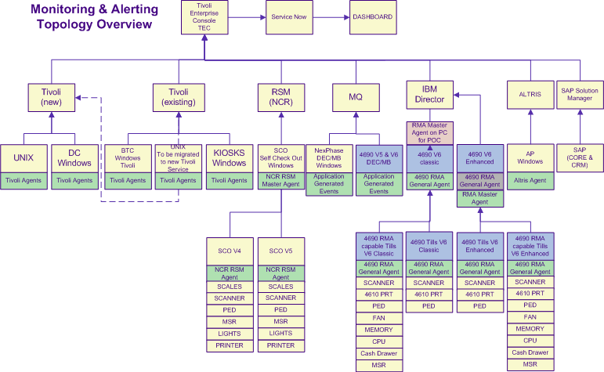

* 1. Other Business Change Implications

It is expected that providing an alerting capability across all stores will lead to a saving in Service Desk Analysts who will not be required to log incident on behalf of the customer. This is not anticipated to be achieved as part of the initial RMA POC.

The standard of IT service provided to the customer should greatly increase due to the ability of the Service teams to react quickly to an alerted or monitored event

It is expected that the near-time alerting will reduce the number of calls made by stores as problems could be identified and resolved before the store experience issues. This is dependant on the type and nature of the issue identified and the processes put in place to manage and react to them.

The diagram below shows the dependencies and migration routes for RMA on the 4690 platform.

While a RMA version is available on V5R2 its capabilities are limited. The prerequisite for the POC is V6R2 4690 Operating System.

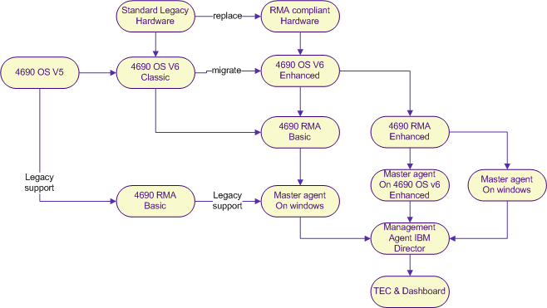

* 1. Business Level Assumptions

It is assumed that RMA is capable of delivering monitoring for all devices attached to a till in both BTC and YLBP stores, and that RMA can be implemented in all stores. This High Level Design will need to validate this assumption and identify what additional hardware or software is required to support the solution. It is also assumed that RMA will trickle feed all event messages in real-time to the centre. These will include System, Hardware, and Application generated events. However, the POC will be limited to a BTC native 4690 installation.

RMA gives us the ability to undertake the following:-

**Power management:** The ability to manage the power states of the POS system. Proper use of this feature can reduce energy consumption and operational costs. This feature is available on compliant hardware.

**Event management:** Indications of immediate and potential problems, thresholds met, or general status information. These events or alerts can be used to triggering both manual and automated corrective actions.

These include:-

* + Hardware events
  + System event
  + Application events
  + Terminal events

The management agent (IBM Director) is capable of providing the following for events/alerts:-

* + - Real-time actions
    - Statistical tracking
    - KPI monitoring
    - Trend analysis
    - Automated recovery
    - Manual intervention

**Operational control and monitoring:** Provides control of the device and elements of the devices operation. Applications can “watch” defined elements in a device for application-defined trigger points.

**Performance monitoring and management**: Overseeing and managing the use of the system resources to best manage performance. Information can be used for system and network resource planning.

**Software distribution**: Software and firmware updates; installation of function on devices.

**Asset tracking and inventory**: Asset tracking for both hardware and software, which can be extremely important to business functions. Asset and inventory tracking is required for use by software distribution tools, and is helpful in understanding and planning fixes.

**Configuration management**: The ability to view and replicate configuration settings for any device in the enterprise. Configuration management also offers the ability to remotely configure or alter the configuration of a device or software element on a device.

All of these functional disciplines, working together, form a comprehensive management solution. While it is not essential that all devices are managed by all disciplines, it is important that that they are managed in a consistent, open and well-understood way.

1. Requirements
   1. Functional Requirements
      1. Summarised / Filtered and Consolidated 4690 EPOS Monitoring and Alerting Functional Requirements for the POC



* 1. Non-functional requirements
* Implementation of a POC on native legacy BTC 4690 Controllers and Tills.
* Determination of capacity and performance requirements of RMA in the Boots Estate, both BTC and YLBP windows tills.
  1. List of Functions Provided

The POC will deliver the following capabilities.

* The near-time transmission of 4690 events and alerts to the centre.
* On-line / off-line notification of tills and controllers and a subset of devices.
* Identification of which general agents are to be configured and executed.
* Configuration for each identified general agent.
* Capacity and performance assessment and implications on the current estate.
* IBM Director as a target reporting tool for the POC.
* An In store PC to host the master agent.
  1. List of Functions Not Provided

The following functions and features will not be delivered as part of the Proof of Concept.

* EPOS hardware attached to YLBP windows tills?
* Implementation on a SIF (Store Integration Framework) controller
* Provision of TEC (Tivoli Enterprise Console) at the centre.
* Provision of a Service Dashboard feed by event from TEC and RMA.
* Migration of 4690 software deployment to IBM Director
* Replacement of the 4690 Capacity Planning database with IBM Director
* Implementation of asset management using IBM Director
* Any 4690 implementation on 4690 OS V6R2 Enhanced mode
* Monitoring of any RF or POD hardware and applications other then events logged by TRANSACT to the 4690 application event log.

Some or parts of the above are expected to be delivered as part of the RMA Phase 2 project which will deliver the strategic solution for enterprise wide implementation.

1. Current Solution
   1. 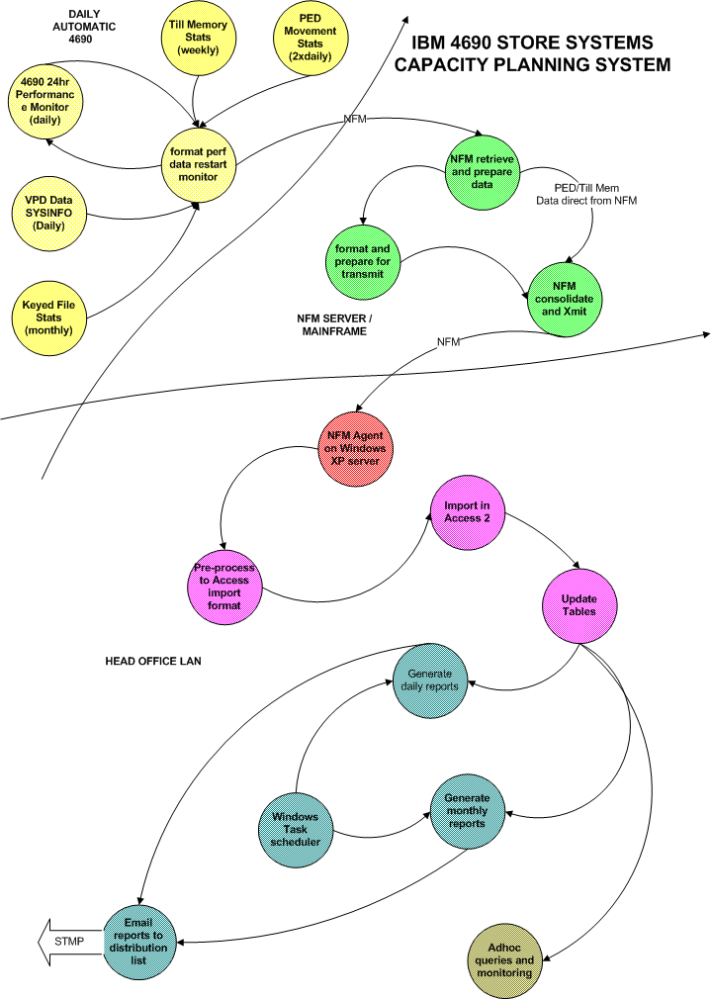Current solution overview
      1. 4690 Capacity Planning System

* 4690 Monitoring task runs 24hrs daily started by SLEEPER the EPOS task scheduler.
* Performance data formatted for retrieval by NFM at 00:00 each night and placed on Capacity planning server.
* Till Memory and PED data retrieved twice daily 7 days a week by NFM and placed on capacity planning server
* Data processing on CP server and loaded in the ACCESS database.
* Automated reports generated and emailed to predetermined circulation list.
* Installed EPOS Controller Report
* Disk Space Warning Report
* Keyed File Performance Warning Report
* PED Movement Report
* PED Firmware Report
* Non production system managed ad-hoc.
  + 1. 4690 Log Retrieval

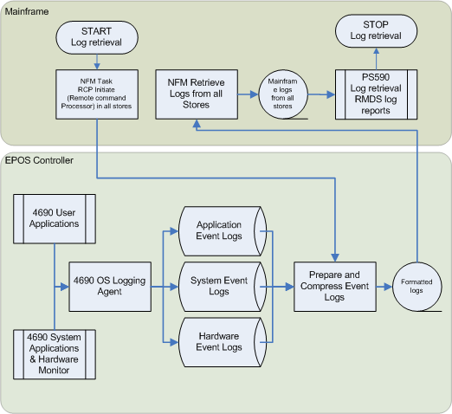

* Events captured in real-time on the 4690 EPOS controller for User Applications, System Applications and Hardware events.
* Events written to a rolling file with date and time details.
* Log file can be wrapped and older events overwritten in the event of an application of device flooding errors.
* The mainframe via NFM initiates the format and compress task on the controller daily (6 days a week).
* Compressed logs retrieved by NFM and decompressed and written to RMDS on the mainframe.
* Logs retained on RMDS for all stores for 7 days.
* Some events trigger other process – EVENT 8 Item refresh, and W754 hard drive failures etc.
  + 1. 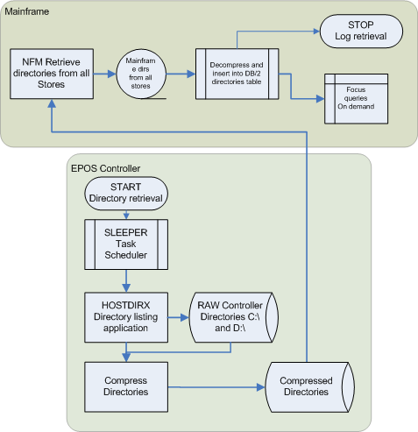4690 Directory retrieval
* Directory task launched by SLEEPER task scheduler on the 4690 daily at 00:00.
* Directories compressed prior to retrieval.
* Compressed directories retrieved by NFM and passed to the mainframe.
* Directories from all stores decompressed on the mainframe
* Directories inserted into a DB/2 database.
* Old entries removed / replaced.
* Database available in both batch and FOCUS for on demand user queries.
  + 1. 4690 Application Suite Status Reporting

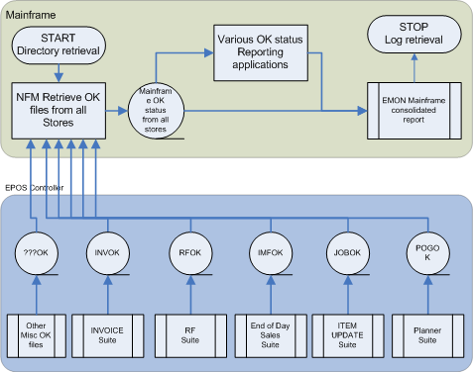

* Numerous mainframe based reports for the status of each suite.
* A single consolidated view produced each morning for the service desk (EMON)
* Most to be replaced as part of CORE
  1. Key points
* All data is batch and bought back overnight after the event for reporting and monitoring. Only PED asset tracking is retrieved during the day (twice) due to its critical nature.
* No / little proactive processes on event logged. Typically wait for the failure to occur.
* Mainframe consolidated reporting will be decommissioned with the CORE programme once sales and stock data is sent to the SAP in real-time. OK messages to become real-time into PI/SAP ECC for housekeeping purposes.
* No single point of reporting or information. Multiple solutions for each desecrate sub-system.
* Developments on the DEC/MB for the CRM/2 and CORE programmes will deliver a real-time event queue for the status monitoring of those new solutions. This could be utilised in the future for general application and operational generated events should RMA not deliver or be suitable.

1. Solution overview
   1. Solution overview & context diagram

IBM 4690 Operating System Version 6 provides support for new IBM hardware, provides access to new technologies, adds configuration flexibility, enhances the capabilities of system management, and increases serviceability. One of these capabilities is the delivery of RMA.

4690 OS V6 introduces a new infrastructure laying the way for the future while continuing to provide the proven benefits of the 4690 OS. As a result, 4690 OS V6 provides two operating modes, Classic and Enhanced. With Version 6.2, Enhanced Mode is provided for both the terminal and the controller. *(*On supported models only – see table later in this document – section 10.5).*

**4690 OS Classic Mode** continues to use the OS infrastructure on which previous releases were based. This mode is intended to allow 4690 OS V6.2 to support the functions and much of the same hardware that have been supported in previous 4690 versions. Some new hardware and new functions available in 4690 OS V6.2 are not supported in Classic Mode. Other new functions are available in both modes. Some 4690 OS V6 functions are available only in Classic Mode.

**4690 OS Enhanced Mode** introduces a new hardware abstraction layer for 4690 OS. The current 4690 OS user interfaces and programming APIs continue to be available allowing current applications to run unchanged in Enhanced Mode. This mode supports additional IBM servers and POS systems not supported by Classic Mode, including selected IBM blade server models, IBM System x3200 M3 models, and the SurePOS 700 models 784/C84.

V6 Enhanced Mode and V6 Classic Mode controllers can be used together in a Multiple Controller Feature (MCF) network. (N.B this is not on the same machine).

**The 4690 RMA Agents** provide the framework for moving store systems inventory, events, configurations, updates, and monitoring data to management applications like IBM Director.

RMA V2 R6 consists of the following two Agents:

* RMA General Agent (GA) - Installed on the 4690 POS systems and supports Classic Mode.
* RMA Master Agent (MA) - Installed on a single system in the store, ISP or Enhanced Controller.

4690 RMA in conjunction with the Management Agent provides the following capabilities, of which a subset will be implemented as part of the POC.

* Remote enterprise management which provides visibility and monitoring of system software and hardware from a single console.
* Inventory management, identifying where systems are deployed and tracking hardware and software versions.
* Remote monitoring of the hardware and peripherals to help prevent hardware failures and outages.
* Automatically identify and predict problems before they cause interruptions in the store and send notifications to a mobile device, email, or start a task to correct the problem without manual intervention.
* Software distribution, updating BIOS, firmware, drivers, OS security patches, and retail applications.
* Power management, Shutdown, Restart, WOL (Wake-on-LAN), Suspend with a Scheduler.
* Create, delete, rename remote directories, view, rename, delete remote files, and transfer files between the store systems and the enterprise with File Transfer.

**IBM Remote Management Agent** along with other IBM Retail Solutions such as **IBM Director**, are the backbone of the IBM Retail Systems Management system that helps you view, track, and control the retail hardware and software environment. With IBM Remote Management Agent you can manage a store or enterprise wide retail operation from a single console.

**DEC/MicroBroker** is a bespoke Boots development that wraps IBM Microbroker to provide an MQ based message transport. This will be used to send some application events to the centre ahead of RMA implementation.

* 1. Architecture Overview Diagram(s)
     1. RMA and DEC/MB Logical Component Overview

The diagram below shows the logical components that will support the monitoring and alerting solution for the IBM 4690 EPOS controller. This will employ a combination of IBM RMA and bespoke developments utilising the DEC/MB message interface.

DEC/MB real-time and near-time events will be implemented prior to any RMA solution as part of CRM/2 (Advantage Card Centralisation) and CORE programs. These will be a combination of process and data events that are to be sent to multiple destinations at the centre. These include SAP CRM, SAP ECC and Tivoli TEC.

This Proof of concept is only concerned with the implementation of the RMA components on 4690 in V6 Classic Mode sending events to an IBM director console at the centre via RMA Master Agent that is installed on a dedicated PC in store.

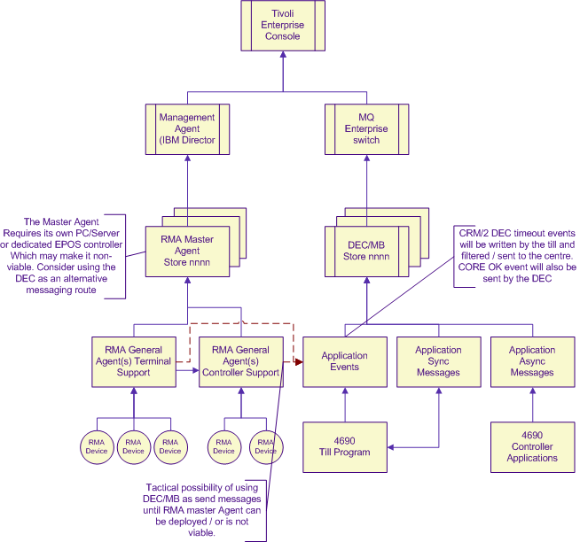

* + 1. Monitoring and Altering Physical Overview

The following diagram shows the physical overview of the EPOS monitoring an alerting solution and the interfaces to the centre to support the solution. There are some outstanding questions to be answered – shown below. The aim of the POC is to ensure all of these are resolved so that we have a full and complete understanding for the strategic solution development.

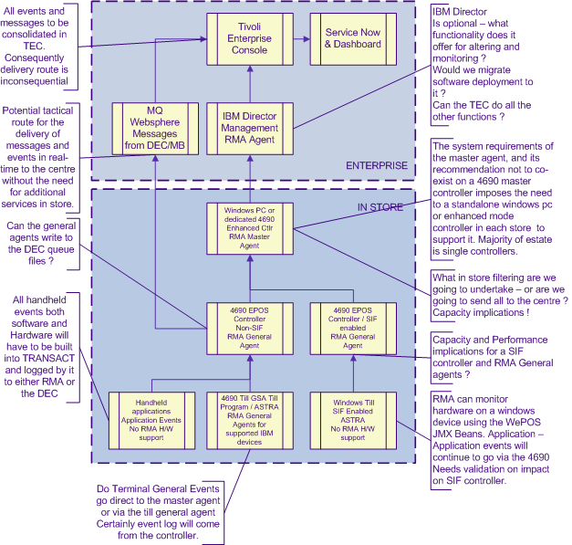

* + 1. RMA 4690 Application Stack

The following diagrams define the software stacks on both the 4690 EPOS controller and the 4690 Native tills necessary to support the IBM RMA solution. Note: 4690 General and Master Agents can NOT co-exist on the same machine, and are therefore exclusive to each other.

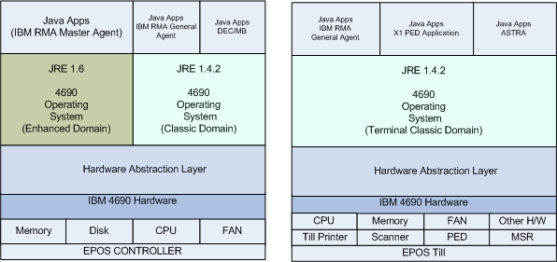

* + 1. RMA General Agent:
  + An incarnation executes virtually on the EPOS Controller for each till in the store, and physically on each EPOS controller that comprises the in store system.
  + Defines manageable attributes and functional entry points, as needed, and exposes them for use within the environment.
  + Defines and issues notifications (Events that are sent to the Master Agent).
    1. RMA Master Agent
  + Provides communication between the management agent and the general agents.
  + Exposes a common collecting interface for all agents in use. (General and Management)
  + Manages filtering and forwarding of notifications to the management agent.
  + Provides a point of implementation and control for store wide activities, such as software distribution and monitor control. (Connections from the central Management Agent)
    1. Management Agent (IBM Director or Tivoli Enterprise Console)
  + Uses the management agent API for interacting with the management general agents
  + Central point of contact and communication proxy for the management application
  + Single presence of the management toolset in the IBM RMA environment
  + Can be located in the enterprise or in store
  + Enables access (either automated or operator driven) to the IBM RMA agent functions
  + Can act as a general agent when run on a 4690 controller in Enhanced mode. (Controller must not be a Master Controller).
    1. Summary of RMA Features on 4690 OS V5R2 and V6R2

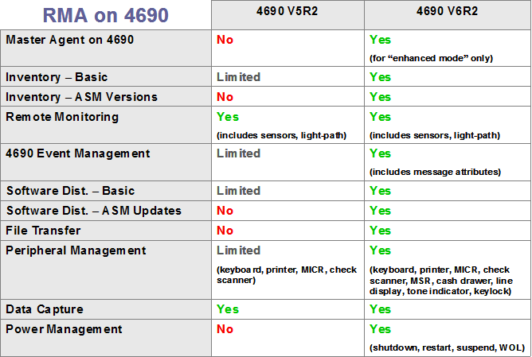

* 1. Summary of alternatives

IBM RMA is the only native integrated monitoring and alerting solution available for the IBM 4690 platform. Bespoke application developments are possible using the new DEC/MB messaging system, and some applications delivered as part of CORE will use this route to notify the centre of process events. It may not possible though to route all Operating System, hardware and application events using this method without changes to the 4690 General Agents. Therefore, it is assumed that if monitoring and alerting is to be implemented on the Boots 4690 EPOS platform a combination of RMA and DEC/MB are the only solutions.

* 1. Key changes
* Migration of the EPOS controller to V6R2 Classic Mode.
* Activation of RMA General Agents for each controller and each till running under 4690 V6 Classic mode operating system.
* Implementation of RMA Master Agent on a standalone PC in 2 Proof of concept stores.
* Central support for IBM Director to take event messages from the store system.
* Capacity and performance regression testing of the system running RMA in POC configuration in Single / Twin
* Capacity and performance testing of YLBP configurations. However, this configuration will not be implemented as part of the POC).

1. Process Design

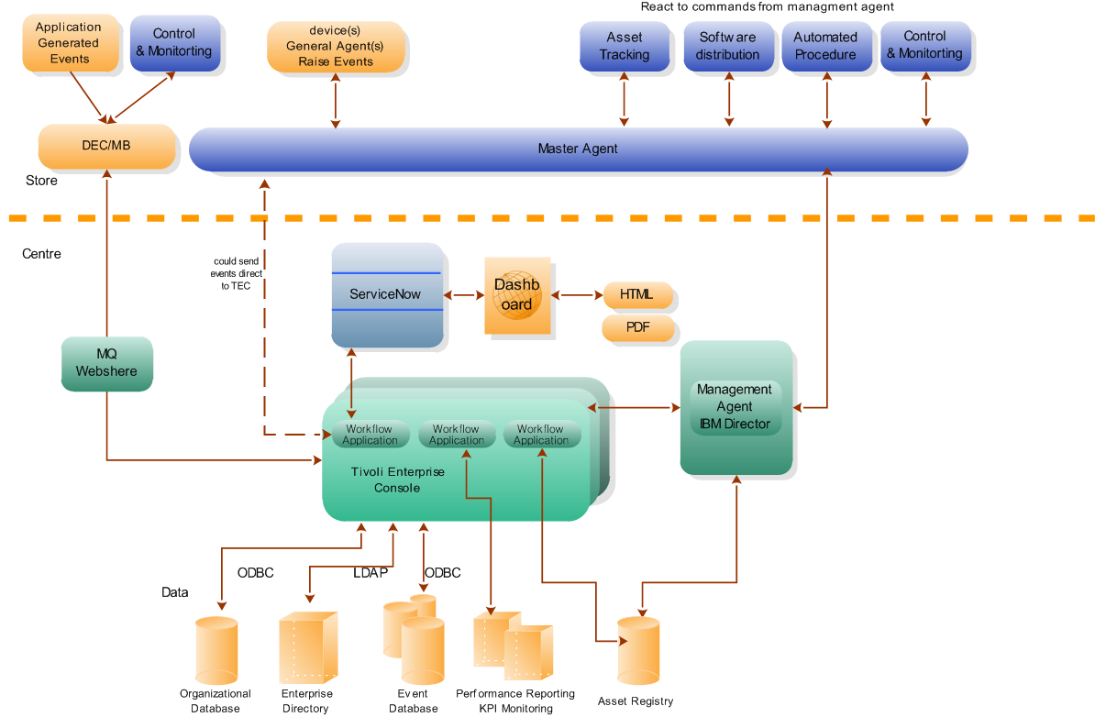

* 1. RMA Store to Centre
* Device general agent generates an event.
* Or Application generates an event.
* Event is written to the 4690 Logs (Hardware/Application/System/Terminal)
* Event sent to Master Agent.
* Master Agent sends event to Management agent
* Management Agent send event to TEC for processing.
* Workflow application at centre determines action for event.
  + Raise real-time ticket and notify service staff via dashboard
  + Store event details for future MI reporting
  + Trigger automated recovery / response process
  1. Centre to Store RMA
* Schedule created for software deployment
* Or Schedule created for asset tracking query
* Or on demand control or monitor request from service user at centre.
* Request sent/executed from Management Agent to Master Agent in Store
* Master Agent executes request or forwards request to general agent if needed.
* General Agent executes request if applicable.

1. Functional Design
   1. Application Components

The IBM 4690 RMA solution is integrated into the 4690 Operating System. Its functionality is switchable via a configuration screen on the EPOS controller for local activation or via a configuration file for remote activation. In either case a controller reload is required to enable the capability. Some agent configuration is also required to control and filter what events and alert are sent to the centre. For the POC the stores will be executing Version 6 Release 2 of the 4690 Operating System. The General Agents run as an embedded agent in a Java Virtual Machine (JVM), as a system service on a 4690 EPOS Controller.

The Master agent will be hosted by a dedicated Windows PC in each of the POC stores. These PC’s will collate and forward the events and alerts to an incarnation of IBM director that will be hosted on a Windows PC in the Service Desk area at the centre. The Master Agent and General Agent services cannot be installed on the same computer, although the Master Agent could act as a General agent too. This however, requires an Enhanced mode 4690 controller, which is also not recommended to be running the tills. (not available in the Boots estate with over 2500 single controllers and around 50 twin controller stores where the alternate master is used to run tills in a failure situation.)

For the POC there are no bespoke application developments, although there will be RMA General and Master agent configurations to create. RMA in general will be executed as it comes out of the box so that we can determine what events and alerts it can generate we need to trap and filter out for a full rollout.

There are some hardware dependencies for RMA. Some monitoring and alerting events will not or can not be generated until RMA compliant hardware is installed, even though RMA compliant software is available. Therefore some alerts and event will be incremental as the rollout of new 4690 hardware is underway. On 4690 operating systems, additional memory is required for each terminal (till) that the controller supports. Testing will need to determine memory and CPU impact for each till, and the constraints this will impose of the Boots estate.

This POC will need to determine and confirm the capacity requirements for RMA. Test lab testing should investigate IBM Director software deployment and power management capabilities, although we do not plan to enable these in the POC stores.

* 1. Data Components

The RMA agents store configuration as properties in a file in the following locations. In Classic mode M:\RMA\USER\RMA\SIMGMT.PRO. In 4690 Enhance mode this becomes F:\RMA\USER\RMA\simgmt.pro. The detailed design will document the properties and the values we shall be using in the Boots implementation. These properties can impact performance and data volumes, so need tobe validated as part of the RMA system testing.

There are two levels of logging employed by RMA. (*ref RMA User Guide – chapter 10*) The Detail Design combined with the output of the testing will need to determine what settings are appropriate for the Boots estate as not to compromise performance, disk space while still providing sufficient information manage the solution. The POC settings may not necessarily be those we use for general production rollout to the estate.

* 1. Interfaces & Integration Components

For the In store components the following components are required:

* 4690 OS V6R2 with RMA V2R4
* Retail Extensions for IBM Director
* Windows Embedded Point of Sale (WePOS) Preloaded V1.1 for YLBP tills. (test lab only)
* Windows XP Professional SP 3 (to host the master agent)

For IBM director at the centre the following components are required:

* The Retail Extensions for IBM Director for IBM Remote Management Agent V2R6
* IBM Director 5.20.3 with Service Update 3
* Windows 2003 Server (x32 or x64)

Network Configuration

* Remote connections to master agents in stores can only use SOXS
* 10151: Java RMI (Remote Method Invocation) Communication between Master and General Agents in stores.
* 10190: RMA File Streaming
* 31200: UPD Port used on Master Agents and General Agents for discovery. The multicast address used is 225.6.29.63
  1. User interface
     1. RMA Master Agent on the Controller

4690 OS V6 provides configuration options to start an RMA master agent on the controller. This is supported on Enhanced Mode controllers only with a minimal supported version of V6R2.

4690 RMA software is provided as part of the base install/migrate package. Installation of a separate System Management package, as in earlier 4690 OS versions, is no longer required.

In System Configuration -> System Settings -> System Management you may specify the controller ID for the master agent in your system. The System Management configuration screen also provides a checkbox to start RMA on all controllers in your system.

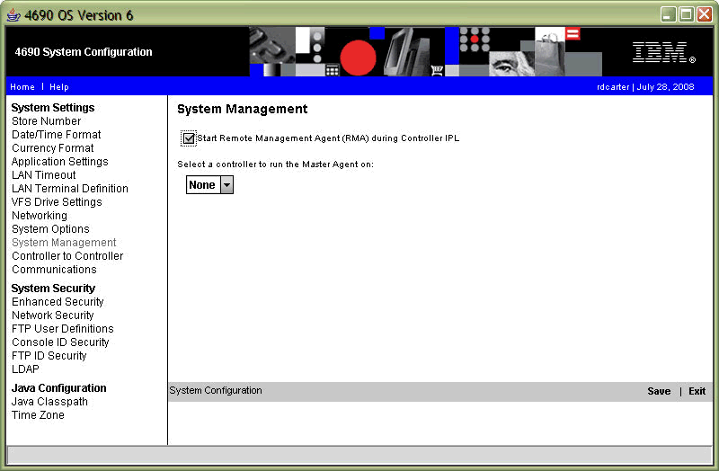

It is not recommended (but not prevented) to run the Master Agent on the 4690 Master Controller due to the workload already being performed by the Master Controller.(*Source IBM RMA Cookbook*) (This has implications for single controller installations which represents 95% of the Boots 4690 Estate, and drives the requirement for an additional Windows PC or Enhanced mode EPOS controller in every store).

Running Master Agent and General Agent on the same machine concurrently is also not supported. The master agent is also capable of providing the general agent functions when installed on an EPOS Controller in Enhanced mode.

* 1. Infrastructure - Technical Components
     1. RMA Additional Device Support
* 4690 V6 expands the 4690 OS V5.2 RMA functionality with additional POS device instrumentation for the following devices:
  + Three track and JUCC MSRs
  + VFD, VFD II, operator (NOT APA nor Alphanumeric) 2 x 20 displays
  + USB 4820 displays
  + Cash drawers on 4800-72x/74x/78x systems
  + Tone and Key lock on previously instrumented POS keyboards
  1. Deliverables and Source

Give a full list of deliverables required, and their likely source.

# A fully regression tested release of the 4690 Operating System V6R2 in Classic Mode.

* A live store implemented on the new release of the 4690 Operating System V6R2 in Classic Mode.
* A regression test of 4690 with RMA active. A focused stability and capacity testing emphasis.
* Regression test plan
* Performance and capacity test plan
* Detail Design - Identified list of general agents to be run
* Detail Design - Configuration settings / files for each agent
* Detail Design – start up sequence of each General Agent
* Detail Design – IBM Director set up and configuration / reports and alerts
* Capacity and performance test for each agent – an assessment of how much memory is required for each till to determine capacity requirements for the largest store, and determine where upgrades would be required.
* 2 V6R2 POC Stores enabled with RMA support active in 4690 OS configuration.
* 2 Windows PC installed in the pilot stores to host the Master Agent Service
* A central implementation of IBM Director on a standalone PC in the Service area to support the 2 POC stores.
* Implementation and removal process documentation.
* An explicit removal plan for the 2 POC stores.
* Network and capacity monitoring of all components of the solution for the 2 POC stores.
* A POC results and way forward plan.

It is anticipated that each deliverable will be delivered as follows:

* Detail Design – RMA for 4690 EPOS Controller and Tills – Agents and configuration by Boots EPOS Development.
* Test plans – IBM EPOS test team supported by the Boots EPOS Development team.
* IBM Director set up and configuration – IBM RSS/RMA support team
* 4690 Operating System – Boots EPOS Development team
* Windows PC’s and Servers IBM WinTel team
* Setup and configuration of Master Agents – IBM RSS/RMA team
* Daily monitoring / analysis and POC assessment feedback – Boots Service.

1. Operational / Service Design
   1. Operational execution

The 4690 RMA service will run continuously on the EPOS Controller, and will by implication have the same availability as the EPOS controller. This is 24x7x365, and will monitor and generate alerts on this basis. The central systems that receive these alerts should therefore be available at comparable times.

The alerts generated can drive a variety of responses. Some will trigger the generation of automatic tickets that appear in near-time on the service Dashboard. Some will result in information being stored for later KPI analysis or reporting, and some will trigger automated processes to be executed. These automated processes could execute at the centre and send data to store or execute on the EPOS controller itself to rectify the reason for the initial event being raised.

* 1. Resilience and robustness

RMA is run as a 4690 system service, consequently it can not be manual stopped or started. The service should be persisted by the 4690 Operating System. If the service fails for any reason, and the operating system fails to recover it, then a reload of the EPOS controller may be required to force a clean restart. Testing should validate that the service failure does no trigger a controller DUMP.

The RMA service can only be stopped by changing the active configuration on the EPOS controller to not start the service on controller reload. Once the configuration has been changed and activated the EPOS controller will need to be reloaded enact the change. The change is not dynamic.

* 1. Failure handling, backup and recovery, DR

It is ironic that a solution implement to report and alert of failures should itself require monitoring, backup and recovery process to be in place. RMA on the 4690 is a fully integrated operating system component. Therefore alert and events that it generates are expected to be written to the existing system event logs which in themselves are monitored by RMA and sent to the centre. This is not the case. RMA maintains its own logs as referenced in section 7.2. The Detail design will identify the logging level and log that are available. The Detail Design should also determine if these logs are required at the centre. If RMA itself fails then the IBM Director console at the centre will see the particular store or controller or till go offline, and raise an alert. The actions, processes, scripts and reporting produced or undertaken following this alert are the outcome of this POC.

No specific changes are required to the existing controller cross disk backup. RMA is implemented into 4690 VFS drive, which in turn is on the physical 4690 System Application directory, and by implication will be backed up. No data is retained or stored on the EPOS controller for RMA.

Standard EPOS controllers cross disk recovery process apply and do not require modification for RMA.

* 1. Service Management

The POC will run for a fixed pre-determined time in two stores only. The solution is not scalable due to the current need to install additional PC/Controllers in each store to host the Master Agent.

The POC solution should not, and must not be reviewed on as a critical service, and should only be conisdered as a fact finding exercise. If the solution fails then efforts will be made by the project team to recover it during normal working hours. No out of hours support will be offered for the POC solution. If the solution proves problematic and has an impact on the POC stores, then the project reserve the write to deactivate and terminate the POC.

1. Development and Testing
   1. Development Approach and Environment

The RMA POC is not anticipated to require any bespoke developments by the Boots EPOS Development team. However, preparation of RMA configuration and activation scripts will be needed. This development and configuration preparation should be undertaken in the EPOS development lab facilities prior to unit testing and packaging for deployment to the System test lab and subsequent POC implementation.

The configuration and deployment process should be fully documented as a Detail Design for the RMA POC. It should be noted that the POC is not a solution that can be deployed to all stores due to the requirements / constraints of the Master Agent, which in turn drives the need for additional PC/Controller in each store.

* 1. Testing Strategy and Environment

The testing of RMA should be viewed as a continuation of the system testing of the 4690 Operating System V6R2 Classic Mode, as this is a prerequisite. A complete regression test is required to ensure that both the operational functions and performance of the system are not compromised by the RMA general agents.

Testing of 4690 V6 enhanced mode and executing the RMA master agent on the epos controller are out of scope for the Proof of concept.

Performance and stress testing should be reflective of the POC target controllers and till load placed up on it for the POC target stores. This is anticipated to be a twin and single controller store with Self Checkout / RF and POD implementations.

Performance impact should be determined by repeating the tests on the same hardware configurations with RMA deactivated.

Testing should be undertaken in the Boots Head Office dedicated EPOS test lab facilities. This is anticipated to be undertaken by the EPOS test team supported by the EPOS Development team.

In order to support the full end to end testing a number of Windows PC’s will be required to host the store master agent and the Central IBM Director Console. Support will be required from the Wintel and Service teams and IBM RSS in the setup and configuration of these systems.

1. Implementation and Migration
   1. Implementation & Migration : options overview
      1. 4690 V6 Packaging and Media

4690 V6 (incorporating IBM 4690 RMA) is distributed with the following media:

•V6 base install/migrate CD

•V6 Classic supplemental CD

The base install/migrate CD supports installation for V6 Enhanced Mode controllers and migration for previous versions of 4690 OS to V6 Classic Mode. In addition, the base install/migrate CD supports the capability to boot V6 Enhanced supplementals. (A system management and installation version of the 4690 Operating System that can be booted from removable media – CD/USB/Floppy disk).

The V6 Classic supplemental CD is used to boot a controller with the V6 Classic Mode supplemental OS. An alternative Enhanced Mode Supplemental CD for use with Enhanced Mode systems can be created using the Enhanced Menu Options on the 4690 V6 Enhanced controller. Use the Enhanced Supplemental CD only with Enhanced Mode systems, the Classic Supplemental CD only with Classic Mode systems.

4690 V5R2 provided separate CDs for install and System Management. These functions are now included with the V6 base install/migrate CD.

* + 1. V6 Base Installation

Installation of the operating system begins by booting the controller from the V6 base/install CD and selecting "Install 4690 OS V6R2" from the boot menu. This process will install 4690 V6 in Enhanced Mode on the controller.

Installation of V6 Classic Mode is not supported.

Boots maintain a rolling system image base, which is maintained via the migration process. It is not anticipated that Boots will need to undertake a clean base build installation at any time in the future; therefore there are no implications from the removal of classic mode base installation in the V6 version of 4690 Operating System.

* + 1. Migration from V5R2 Classic to V6R2 Classic

4690 OS V6 supports migration to V6 Classic Mode from V5R2. This is the current version being used by Boots in both BTC and YLBP 4690 stores today.

Both local and remote migration options are supported.

A local migration begins by booting the controller under its current 4690 OS level, then initiating migration through the "P:\4690migr\start" command provided on the 4690 V6 base install/migrate CD.

* + 1. Conversion from previous 4690 versions to V6 Enhanced

To convert a system using a previous version of the OS to a V6 Enhanced controller, the following procedure can be used:

* 1. Migrate the source system to 4690 V6 Classic from a previous, supported OS version.
  2. Ensure the source system has the V6 Multiple Controller Feature (MCF) installed, configured, and is acting master.
  3. Boot the target controller using the V6 Enhanced Supplementals CD or boot from the V6 install/migrate CD and select "4690 Supplemental OS" from the boot menu.
  4. Use CPREP to format the hard disk on the target controller. This step prepares the system to run in Enhanced Mode. You must CPREP with the Enhanced CD media version of the Supplementals to convert to Enhanced Mode. Additionally, use DPREP if an additional drive is present.
  5. Use the Disk Rebuild utility on the target system to copy the data from the source system.
     1. Summary: How to Select Enhanced or Classic Mode
  6. Enhanced controllers are created through installation, or through CPREP/DPREP -- using the Enhanced CD media version of the supplemental boot disks -- followed by a disk rebuild in an MCF network, or copy of a recovery image.
  7. Classic controllers are created though migration, or through CPREP/DPREP -- using the Classic CD media version of the supplemental boot disks -- followed by a disk rebuild in an MCF network, or copy of a recovery image.
  8. Technical transition

It is proposed at this time that the majority of the existing 4690 EPOS controller estate can be upgraded via the migration method described above. The standard remote transmission of the migration package over the store network, and placed into the standard ASM (Apply Software Maintenance) holding directories. The upgrade will be executed and monitored remotely.

For stores where the existing EPOS controller can not support the solution, then a controller replacement will be required. This will involve the source system being copied onto the new replacement controller through the CPREP/DPREP and supplemental boot disk process by an onsite engineer. Once the new controller is in place then the migration package can be deployed remotely.

It is not possible to parallel run the solution. For the pilot stores the system can be implemented using ASM test mode capability. This will provide the ability to back out the implementation in the event of problems or issues.

Once we progress to general rollout following a period of extensive pilot the ASM migration is normally implemented in commit mode. The pilot stores can be moved from test to accept, and thus removing the ability to cancel (roll back / uninstall). It is possible to undertake general roll out in test mode. However, this would then require a following accept package to clean up the ASM backups.

RMA mode for tills depends on the model of till installed in each store location. As the non RMA compliant tills are replaced then a process will be required to configure the new tills to load and execute the RMA agents as and when they are replaced. This is expected to be a combination of automated pre-defined configuration and manual processes by the installation engineer.

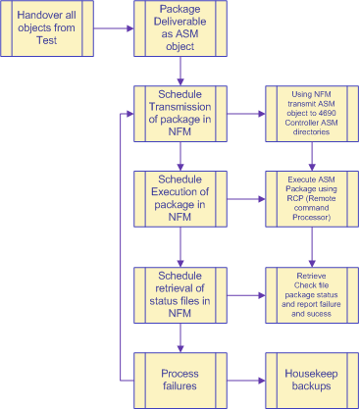

* 1. Data cleansing and migration

RMA has the potential to generate significant volumes of data. If the agents in store are not configured correctly there is potential for them to generate high numbers of alerts and events. It is important that service identify at an early stage which events are required and will drive process / action / reporting, and those which can be discarded.

There a numerous reasons why this is important.

* Reduce impact and CPU / resource usage by the master agent in consolidating and filtering events from the general agents.
* reduce impact and bandwidth requirements on the store to centre network by not sending redundant messages / events to the centre
* Reduce the impact on the central management agents (IBM Director, Tivoli Enterprise Console and the Dashboard) from being clogged up with unwanted data.

There will be point during the implementation where both legacy reports and new methods of monitoring will be used on the service desk. Additional resource may be required during the transition period to enable the management of both solutions. Longer term it is expected that efficiencies resulting from the consolidation of data and the pre-emptive alerting in real-time can be delivered.

There is no legacy data that needs to be retained from the mainframe based log retrieval. It is assumed that all the legacy data in the current Capacity planning system will be retained and imported into its replacement once it has been defined.

* 1. Decommissioning old systems and data

The existing batch based solutions will become redundant. These can then be decommissioned once the deployment by the CORE programme has replaced the main mainframe batch systems for inbound and outbound data. Currently the controller application event logs are parsed by the mainframe for *item refresh event 8’s* which trigger master data refresh in the outbound to that particular store. Other applications such as EMON on the mainframe parse the logs for other events such as W574 pending disk failures etc, and trigger actions by the service desk. It is anticipated that this will be replaced by the dashboard project that will take real-time events from *TEC/Service Now* and present them on the Service dashboard.

* 1. Hardware Requirements -- Controllers
* The General Agent requires a minimum 1GHz processor with at least 70MB of free memory when running in a Windows environment.
* On 4690, additional memory will be required depending on the number of terminals the controller supports.
* The Master Agent requires a minimum 1GHz processor with at least 1GB of system memory.
* Minimum/Maximum controller memory (Classic Mode) - 128 MB/1 GB
* Minimum/Maximum controller memory (Enhanced Mode) - 512 MB/1 GB
* Although 1GB is the maximum usable memory in a 4690 OS V6 controller, up to 2GB can be installed for Enhanced mode (assuming the controller model supports it.)
* Controller NVRAM is required for Enhanced and Classic controller modes. NVRAM is integrated in SurePOS 700 system. System x and Blade Servers require an NVRAM card.
* Enhanced controllers only support Ethernet LAN communications.

The following table shows controller and controller/terminal models supported in Classic and/or Enhanced Mode on 4690 OS V6:

|  |  |  |  |
| --- | --- | --- | --- |
| **Model** | **Enhanced Controller** | **Classic Controller** | **Controller/**  **Terminal** |
| SurePOS 700: 4800-741,781,722,742,782,723,743,783 | X | X | X (Classic Mode only) |
| SurePOS 700: 4800-C41,C42,C43 | X | X | NO |
| HS12 blades: 8014, 8028 | X(SATA and SAS models) | docview | docview NO |
| BladeCenter S Chassis 8886-MAZ | X | docview | docview NO |
| IBM System x3200m2  4367,4368-xxx | X(SATA and SAS models) | X(SATA only) | docview NO |
| IBM System x3200  4362,4363 | X | X | docview NO |
| eserver 206m:  Series x 206m: 8485,8490 | X | X | docview NO |
| Xseries 206:  8482,8487 | X | X | docview NO |
| Xseries 205:  8480 | X | X | docview NO |
| HS20 Blade | X | X | NO |

* 1. Hardware Requirements -- Terminals
     1. Memory Requirements
  + Minimum terminal memory with Java™ - 128 MB
  + Maximum terminal memory - 512 MB (for those 4694 and SurePOS™ 700 terminals that can run 512 MB)
  + Only the IBM SurePOS 700 Series and select models of the IBM SurePOS 4694 POS System can run Java applications.
    1. Supported Terminals

4690 OS V6 terminal support when using Classic controllers remains unchanged from 4690 OS Version 5.2. Enhanced controllers only support Ethernet LAN communications. Terminal models using store loop or token ring network communications can not be used with the Enhanced controller.

* 1. Hardware Requirements -- IBM Director Server
* The Retail Extensions for IBM Director for IBM Remote Management Agent V2R6
* IBM Director 5.20.3 with Service Update 3
* Windows 2003 Server (x32 or x64)

RMA Proof of Concept on 4690 OS V5R2

* + 1. Environment used for testing.

**4690 Setup**

Twin controller (2x SurePos 742) system running 4690 V5R2 at CD0800, Boots software level 10A.

Tills – 1 x SurePos 733, 1 x SurePos 742.

Changes made to 4690 system – RMA software added and configuration changed to start RMA at IPL.

**Windows environment**.

2 x Windows XP where used. One to run the RMA master agent and the other running IBM Director.

* + 1. What 4690 events RMA/IBM Director can capture.

All of the 4690 logs are sent onto IBM Director and can have ‘Events’ performed on them by IBM Director. This is only possible if the event uses a specific message number in the message text. A problem arrises for Boots Application Events were we log all application events using message number J000 and vary the event number.

Alarmed messages logged by BGMON are OK as these log against specific message number (J996 etc).

IBM Director can trap 4690 Events logged by tills. However, the till number does not appear as part of the message, so an alert would only be possible against the store number.

* + 1. 4690 Events that have been setup during the testing.

IBM Director events have been setup to check for Sales and Stock Support Abended messages, controller dumps and controller reloads.

Till offline checks have also been setup. Unlike 4690 events that where not logged against a till number, tills (and controllers) going offline can be reported directly by IBM Director so they can be logged against a till number.

* + 1. What cannot be performed with the current 4690 O/S.(V5R2)

Resource monitoring (i.e. drive space reporting).

Inventory and asset management.

Terminal peripheral monitoring.

* + 1. Things to be careful of when creating ‘Event Action Plans’.

Event Action Plans (EAP) is a plan of what IBM Director will do when it sees a particular event.

If care is not taken multiple actions (calls being logged) could happen for a single problem. An example of this would be when Stock Support abends, as the event is logged by BGMON and event would be logged every 15 minutes until Stock Support is re-started.

An EAP can be setup to ignore duplicate events within a set time period. Likewise, an EAP could be set to only perform an action if the event was logged a set number of times within a time period, this could be useful for controller and till reloads to only log a call if the same event happens twice in an hour.

* + 1. Issues.

Times being reported different in IBM Director against 4690 (1 hour different). This will be a problem with Time Zones being different between the machines, 4690 does not have a time zone for British Summer Time.

Dates being shown in American format (event log).

* 1. Risks, Issues and Assumptions
  2. Architectural Decisions and Assumptions
* It is assumed that the 4690 RMA General Agent will be deployed to all EPOS controllers in both the BTC and YLBP estates.
* It is assumed that the 4690 RMA General Agent will be deployed for all tills in the BTC estate.
* It is assumed as terminal (till) general agents run virtually on the EPOS controller, that all SI tills are supported.
* It is assumed that the Master agent will run on a standalone PC in store (for the POC). This may not be the case for the general rollout.
* It is assumed that the messaging solutions for RMA and DEC/MB can co-exist on the same 4690 EPOS Controller.
* It is assumed that there are no capacity or performance implications on network traffic and messages via the DEC/MB for CRM/2 and CORE as a result of RMA.
* It is assumed that there is no impact on trading ability and till performance and consequently till transaction times as a result of RMA.
  1. Issues and Risks
* It is not recommended (but not prevented) to run the Master Agent on the 4690 Master Controller due to the workload already being performed by the Master Controller.
* Controller memory and CPU may suffer and identify problems on SI controllers.
* Boots 4690 estate is 90% single controller implementations, some of these have up to 50 tills installed.
* There are a large number of old X205 controllers in the estate that may not support the rollout solution on capacity grounds.
* Store Integrator (SI) is supported running 4690 V6 Classic Mode only at this time – hence can’t host the Master Agent or Enhanced mode in YLBP. YLBP stores currently use SI V1; plans are in place to migrate to SI V2 during 2011.
* SI is being rolled out to BTC stores as part of stores refresh programme to support Windows Service Tills. SI is only supported in 4690 Classic Mode as this time. Hence it is not possible to implement Enhanced mode on an SI 4690 Controller.
* Issues identified in the 4690 V5R2 POC around event trapping have not been resolved, and may still exist. Test to validate either way.
  1. Limitations
     1. Hardware limitations
* IBM 4690 OS V6 ONLY runs on IBM hardware.
* IBM 4683 and 4693 terminals can support only the IBM 4690 OS V1 functions, not the Java or terminal-based TCP/IP functions, and, as a result, system management functions are not supported on these terminals.
* The PS/2 attached IBM Modular ANPOS keyboard will be supported in compatibility mode only and will not support firmware flashing.
* Controller displays must be able to support SVGA 800 x 600 screen resolution for Enhanced Mode.
  + 1. Software limitations
* Java 1 has been removed from 4690 OS V6 and is not supported.
* 4690 Remote Access is only supported in Classic Mode.
* Store Integrator (SI) is supported running 4690 V6 Classic Mode only at this time.
* Support for virtual sessions in 4690 - V6 Enhanced Mode is not available at this time.

## Index

1. Preface 1

1.1 Introduction 1

1.2 Scope of Document 2

2. Business Context 2

2.1 Business Objectives 2

2.2 Business Process Scope 2

2.3 Other Business Change Implications 3

2.4 Business Level Assumptions 3

3. Requirements 5

3.1 Functional Requirements 5

3.2 Non-functional requirements 6

3.3 List of Functions Provided 6

3.4 List of Functions Not Provided 6

4. Current Solution 7

4.1 Current solution overview 7

4.2 Key points 8

5. Solution overview 9

5.1 Solution overview & context diagram 9

5.2 Architecture Overview Diagram(s) 10

5.3 Summary of alternatives 13

5.4 Key changes 13

6. Process Design 14

6.1 RMA Store to Centre 14

6.2 Centre to Store RMA 14

7. Functional Design 15

7.1 Application Components 15

7.2 Data Components 15

7.3 Interfaces & Integration Components 15

7.4 User interface 16

7.5 Infrastructure - Technical Components 17

7.6 Deliverables and Source 17

8. Operational / Service Design 18

8.1 Operational execution 18

8.2 Resilience and robustness 18

8.3 Failure handling, backup and recovery, DR 18

8.4 Service Management 18

9. Development and Testing 19

9.1 Development Approach and Environment 19

9.2 Testing Strategy and Environment 19

10. Implementation and Migration 20

10.1 Implementation & Migration : options overview 20

10.2 Technical transition 21

10.3 Data cleansing and migration 22

10.4 Decommissioning old systems and data 22

10.5 Hardware Requirements -- Controllers 23

10.6 Hardware Requirements -- Terminals 23

10.7 Hardware Requirements -- IBM Director Server 23

RMA Proof of Concept on 4690 OS V5R2 24

10.8 Risks, Issues and Assumptions 25

10.9 Architectural Decisions and Assumptions 25

10.10 Issues and Risks 25

10.11 Limitations 25

**Document Information**

| **Document Owner** | Paul Bowers |
| --- | --- |
| **Document Owner Job Role** | Senior Solution Designer (Retail) |
| **Author** | Paul Bowers |
| **Next Review Date** | June 2011 |

**Reviewer(s)**

| **Reviewer(s)** | **Title** | **Reviewer(s)** | **Title** |
| --- | --- | --- | --- |
| Janet Zobel | Business analyst | Richard Nicholas | EPOS Delivery Manager |
| Ann Greener | IBM EPOS Test Manager | Jamie Thorpe | Solution Designer (Retail) |
| Matthew Brown | Service Team Lead | Tom Parking | Service Team Lead |
| Tracey Tench | Service (Stores) | Justin Loftas | Service Tools PM |
| Andy Staples | Program Lead Alerting & Messaging | Phil Yardley | Project Manager |

**Authorisation**

| **Name** | **Title** | **Signature** |
| --- | --- | --- |
| Gary Newbold | Lead Architect (Middleware) |  |
| Allan Dyer | Senior User |  |
| Nigel Shortt | Head of Delivery (Retail) |  |
| Dave Cottom | Service Development Manager / Project Sponsor |  |
| Peter Smith | Head of Delivery (Infras’re) |  |
| Steve Brown | Head of Delivery (Service) |  |
|  |  |  |

**Related documents (if any)**

| **Document name** | **Location** |
| --- | --- |
| IBM RMA CookBook .PDF | <http://www-01.ibm.com/support/docview.wss?rs=219&uid=pos1R1004377> |
| IBM RMA User Guide.PDF | http://www-01.ibm.com/support/docview.wss?uid=pos1R1004204 |
|  |  |

**Document History (previous version only)**

| **Previous Version No.** | **Date** | **Reason for Change from this** |
| --- | --- | --- |
| 0.2 | 3/7/11 | Design Authority approval |